Report of Project 1
Jinglin Li (jxl163530)

First program. Display continuous changes for the xy and Luv representations.

General steps:
- xyY => XYZ => Linear sRGB => Non-linear sRGB
- Luv => XYZ => Linear sRGB => Non-linear sRGB

Note:
- when xyY => XYZ, if y = 0, then X = 0, Z = 0;
- When calculate sRGB, they are in the range of [0, 1]. Out of range values are clipped.
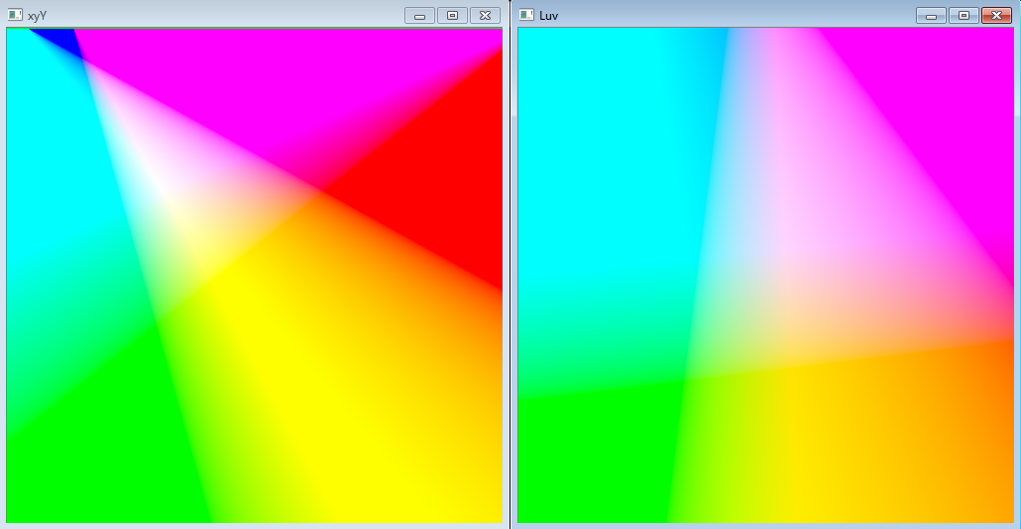
The results are beautiful and shows continuous color

Second program. Linear scaling in Luv
Arguments: 0.3 0.3 0.7 0.7 fruits.jpg out.bmp

General Steps:
- Find the smallest L and Largest L in the window (0.3, 0.3, 0.7, 0.7)
- Apply into the whole picture, pixels => Luv
- Linear scaling on L , using the smallest and largest L in the window
- Convert back from Luv to pixels

Note:
- When find the smallest L and Largest L in the window, only Y is needed.
- When XYZ => Luv, if the d = 0, then u’ = 0 and v’ = 0.
- When Luv => XYZ, if v’ = 0, then X = 0 and Z = 0.
- When calculate sRGB, they are in the range of [0, 1]. Out of range values are clipped.

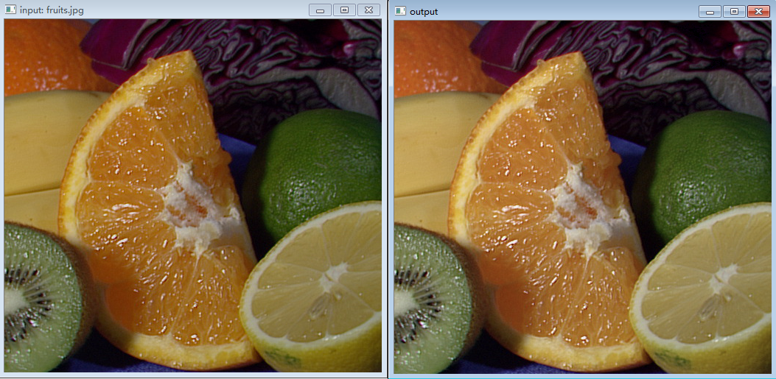
The result is brighter.

Third Program. Histogram equalization in Luv.
Arguments: 0.3 0.3 0.7 0.7 fruits.jpg out.bmp

General Steps:
- Find the L in the window (0.3, 0.3, 0.7, 0.7)
- Find the ceiling of L by calculate L as (int)L + 1 if L < 100.
- Increment the array to count the numbers in the range [i – 1, i]
- Calculate the b[i] as f(i) and c[i] as the final L values
- Apply into the whole picture, pixels => Luv
- Histogram equalization on L , using c[i]
- Convert back from Luv to pixels

Note:
- Same to the previous program.
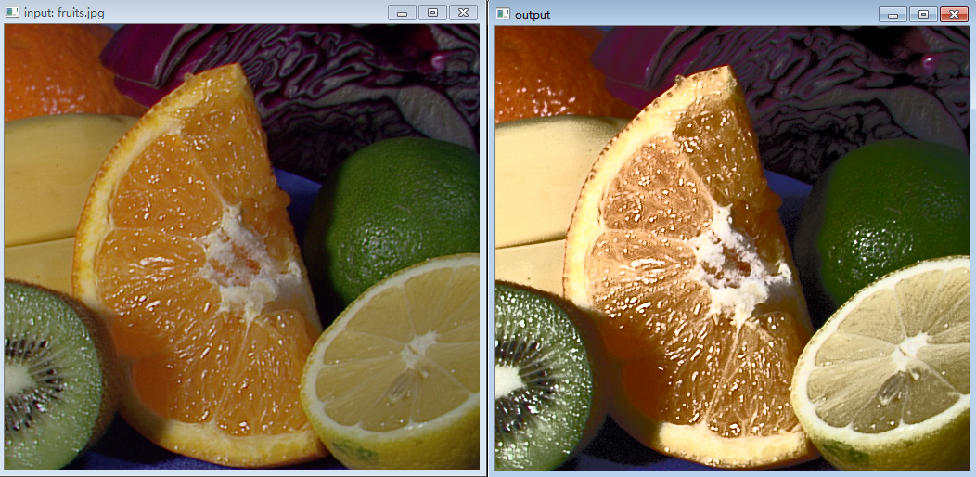
The result looks “bad”. Because we use the L in the specific window to perform the histogram equalization for the whole picture.

Fourth program. Linear scaling xyY.
Argument: 0.3 0.3 0.7 0.7 fruits.jpg out.bmp

General Steps:
- Find the smallest Y and Largest Y in the window (0.3, 0.3, 0.7, 0.7)
- Apply into the whole picture, pixels => xyY
- Linear scaling on Y , using the smallest and largest Y in the window
- Convert back from xyY to pixels

Note:
- When calculate sRGB, they are in the range of [0, 1]. Out of range values are clipped.
- Others are similar to the previous program.
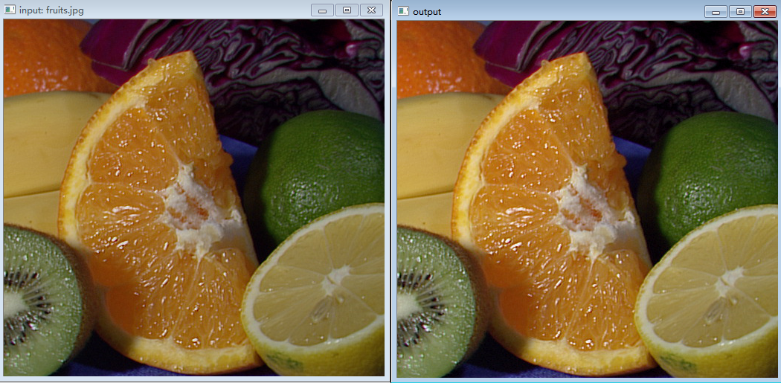
The result seems brighter.

